**ASSIGNENMENT NO 1: - DOCKER**

You have GitHub repository with 3 branches- (Eg: 23Q1, 23Q2, 23Q3).

Each branch has its own individual index.html file.

We have docker machine and 3 containers- 23Q1, 23Q2, 23Q3 (port- 80,90,85)

Now let’s create a Jenkins pipeline job and deploy index.html inside respective containers (Eg: index.html of 23Q1 branch be deployed on container 23Q1 and so on…)

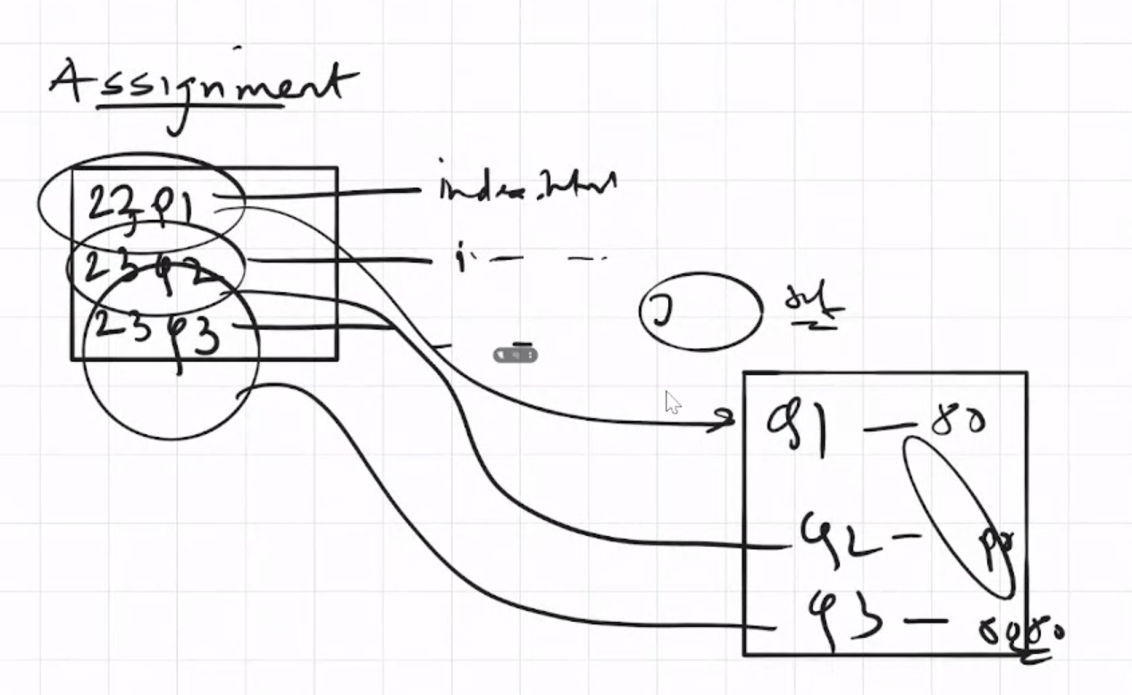

**STEP 1:** Launched one EC2 Linux server and installed below software’s first:

* Git
* Java 11, Apache Tomcat & Jenkins.war
* Docker

**STEP 2:** Created a GitHub central repository, with three branches, and each branch has its own index.html file.

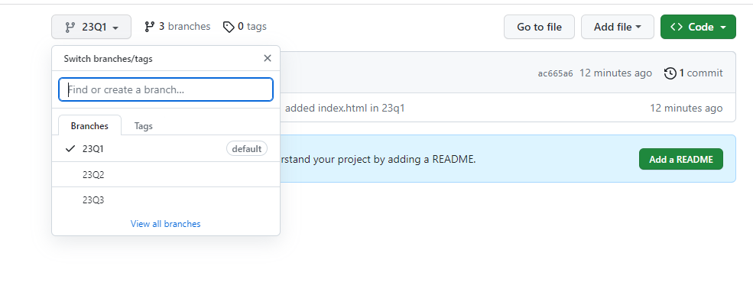

**STEP 3:** Installed docker on EC2 server.

# yum install docker -y

# systemctl enable docker

# systemctl start docker

**STEP 4:** Created 3 containers from httpd image:

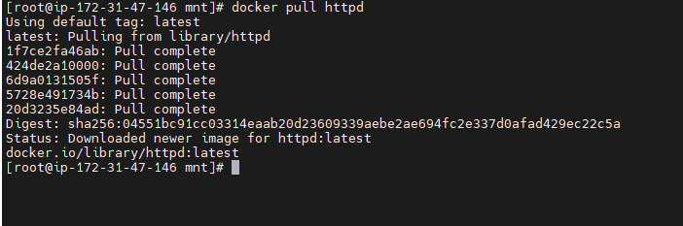

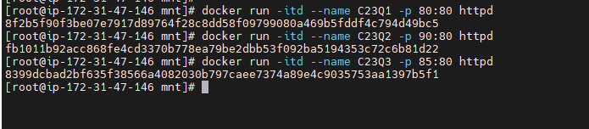

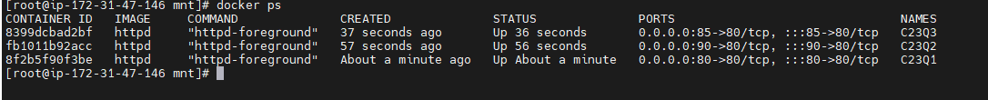

**STEP 5:** Created Jenkins Pipeline job:

Note: go on manage Jenkins 🡪 nodes -🡪 built-in node 🡪 label (build-in) 🡪 save it and do build now.

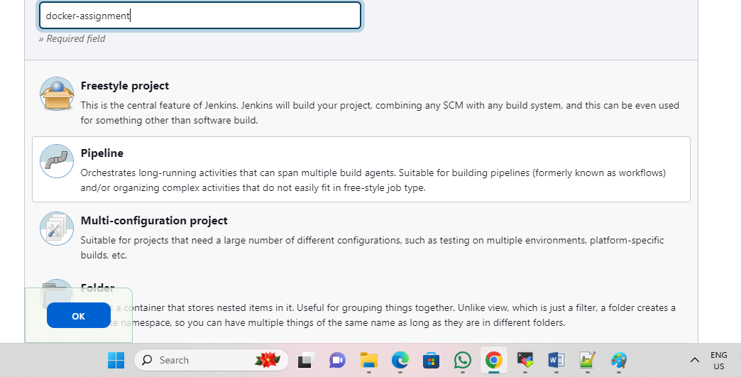

**STEP 6:** Successfully build the Job:

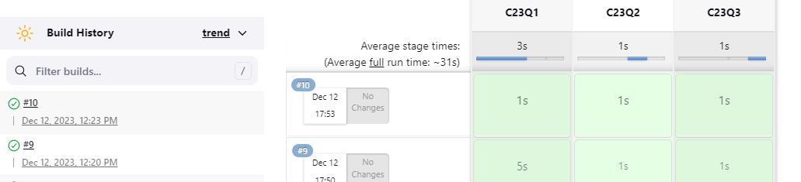

**SCRIPT USED:**

|  |
| --- |
| /*ASSIGNENMENT 08: - DOCKER  You have GitHub repository with 3 branches- (Eg: 23Q1, 23Q2, 23Q3).  Each branch has its own individual index.html file.  We have docker machine and 3 containers- 23Q1, 23Q2, 23Q3 (port- 80,90,8080)  Now let’s create a Jenkins pipeline job and deploy index.html inside respective  containers (Eg: index.html of 23Q1 branch be deployed on container 23Q1 and so on…)*/  pipeline{      agent{          label{              label "build-in"              customWorkspace "/mnt/workspace"          }      }      stages{          stage("C23Q1"){              steps{                  sh "rm -rf *"                  git branch: '23Q1', changelog: false, poll: false, url: 'https://github.com/pskarne/multi-branch.git'                  sh "chmod 777 index.html"                  sh "docker cp index.htnl C23Q1:/usr/local/apache2/htdocs/"              }          }          stage("C23Q2"){              steps{                  sh "rm -rf *"                  git branch: '23Q2', changelog: false, poll: false, url: 'https://github.com/pskarne/multi-branch.git'                  sh "chmod 777 index.html"                  sh "docker cp index.htnl C23Q2:/usr/local/apache2/htdocs/"              }          }          stage("C23Q3"){              steps{                  sh "rm -rf *"                  git branch: '23Q3', changelog: false, poll: false, url: 'https://github.com/pskarne/multi-branch.git'                  sh "chmod 777 index.html"                  sh "docker cp index.htnl C23Q3:/usr/local/apache2/htdocs/"              }          }      }  } |

**-: OUTPUT :-**

Output from container 1

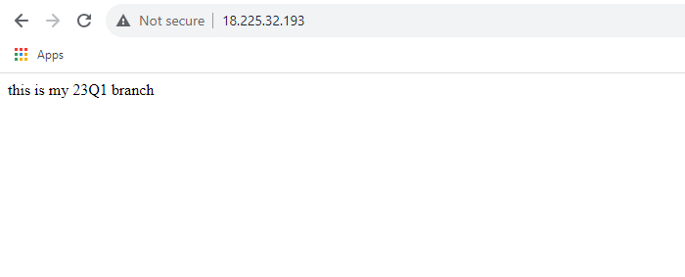

Output from container 2

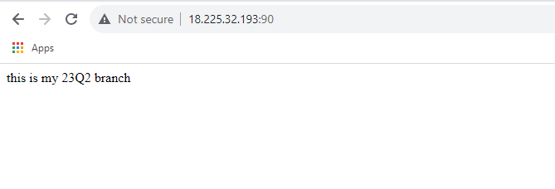

Output from container 3

